Term Project Proposal

Cassidy Kane

11/13/2019

## Description

Overlapper superimposes two images in the style of photographic multiple exposure. Upload two images and use the Seek Bar to control the degree of overlap between them. The Seek Bar controls the opacity of each image in relation to the other.

## Widgets

-Text Views will be used for labels.

- Edit Texts will be used to receive user input of image urls.

- A Seek Bar will be used to adjust the opacity of the overlapped images.

- An Image View will be used to display the overlapped images.

- Buttons will be used to switch between views.

## UI Mockups

First Activity

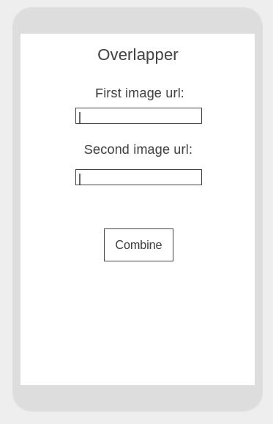

Second activity

